§ Please read carefully before using §

WIND TURBINE

ELECTRICAL AUTOCONTROLLOR

---OPERATION MANUAL---

Contents

Summarize……………………………………..3

Operation process……………………..............4

Operation step…………………………………5

Liquid crystal screen operation and display…6 Box diagram……………………………………9

Accident analysis………………………………10

Notice…………………………………………...10

The Maintenance of the Batteries…………….11

Wiring diagram………………………………..13

Schematic diagram……………………………13

Technical Parameters…………………………14

2

ⅠSummarize

ZKJ-B wind turbine auto-controller is special matched equipment with wind turbine. It commutates the AC that generated by wind turbine to DC and then charges to storage battery groups.

ZKJ-B auto-controller with a beautiful appearance, simplify indication, easy operation, has an auto-protection function in case of battery converse connection; auto-shunt in case of heavy wind (unload). The wind turbine shut down automatically when the battery group voltage get to 125%; and startup automatically when the voltage drop to 108%. The key component adopts the high-efficient chip control, the complete machines is intelligent. This system is running safely, steadily, and reliably, working efficiently and have a long work life, which is proved by a large number of experiments.
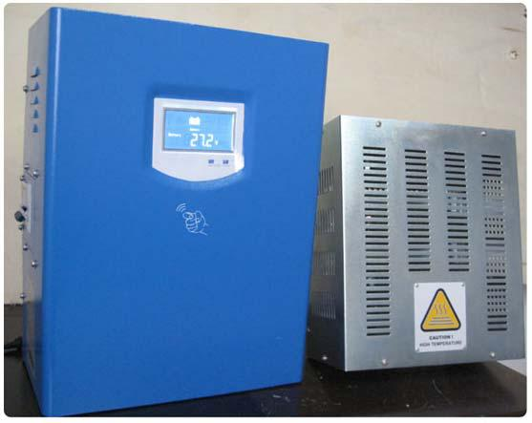

- Operation process

- Out-linked wire

1）. Connect the “+” & “-”poles of storage battery separately to the back panel’s

3

battery “+” & “-” poles (or terminal blocks) of the charge controller.

Take strict precautions against wrong polarity connection or short circuit.

2）. Connect 3-phase output wires of wind turbine separately with the connectors on the controller’s back panel (No order among A.B.C)

3）. Connect the shunt (unload) of the turbine with a, b, c terminal blocks on the back of the controller separately.

4）. Connect the “+” & “-”poles of solar separately to the back panel’s solar “+” & “-” poles (or terminal blocks) of the charge controller.

2. Caution: When the poles are wrongly connected, blowout, reversed indicator

will shine.

1）When the battery’s voltage is lower than the discharging bottom limit (see the details in the attached form), the shortage indicator shines, it reminds the user that it is in the discharging lower limit and needs charge.

2）When the charging fuse breaks, the charging fuse indicator will shine to remind the user to change the fuse.

3）When the wind turbine is working, it is not allowed to open or change the fuse, so as to avoid the user from being hurt or damage the machine. When user change the fuse, the wind turbine should in brake state, shut off all the switches, braking the connection of the battery and then check or change the fuse.

4）When the wind speed is too high or the storage battery is close to enough charging, the shunting boxes works and the shunt indicator shine. At this moment the wind turbine continue charge little electric current into battery.

5）When the battery is sufficiently charged and the voltage get to125%, the wind

4

turbine will automatically stop charging and the stop indicator will shine at the same time. There is no indication for the Ampere Meter. When the battery voltage drop to 108% of the rated voltage, the stop indicator and shunt indicator will quench and the wind turbine will resume to work and then charge to the battery automatically.

3. Manual brake switch

1）After connected the storage battery correctly, press the button to “RUN” position on the side panels, the turbine is under the condition of automatic working. (Small power controller with this equipment, larger power charger controller user will self-provided to install)

2）Press the wind turbine button to “STOP” position when without using this machine.

3）It is forbidden to operate the manual breaking switch when the wind turbine is working.

- Operation step

- When installing or regular maintaining the special power supply for the

wind turbine, you should follow the below operation steps.

1） Before operation, put the manual switch in “OFF” position, and make the wind turbine in stop state.

2） After connect the shunting box with the controller, connect the output wire of the wind turbine with the A B C output terminal of the controller.

3） Connect the controller and the battery. Forbidden to connect the battery “+” and “-” pole conversely.

5

4） Connect the controller and the solar. Forbidden to connect the solar “+” and “-” pole conversely.

2. Notice

1）. Before installation and operation, please shut off all the electric power. And then install them orderly.

2）. The controlling switch must be added to the battery group.(>60V) Also it should be operated by a career-man to avoid being hurt.

2. Working conditions

1）Using in dry, clean, ventilated environment.

2）Avoid direct sunshine, insolate, drench, damp, and acid mist.

3）Avoid using in dusty environment.

4）No less than 1.5-2 meters far from the storage battery.

5）.This machine must be fix up on the dry insulated panel, and add the anti-dust cap. Placed in ventilated place.

6）. When the shunting box matched with the machine work, there is a high temperature, so it should be placed in a ventilated place. The matched shunting box should not be covered and no flammable, explosive things nearby.

- Liquid crystal screen operation and display

（1）. Operation explanation

Striking the front panel of the case， LCD screen light. Each knock, parameters change again. Stop the operation 1 minute, LCD screen automatically put out, to save electricity.

（2）. Display explanation

LCD screen complete content

6

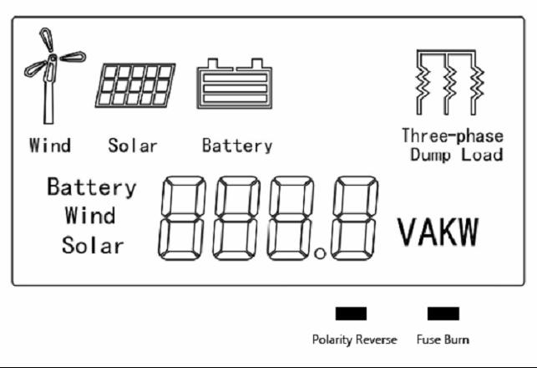

Image Explanation
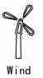

Wind turbine

The wind turbine images display showed that wind generators

running normally.
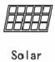

Solar panel

The solar panels images display showed that solar panels working

normally.

Battery
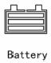

Battery internal strip graphics showed battery power.

When the battery charged enough, the battery voltage reached 125% of the rated voltage. The wind turbine will automatically carry out three-phase dump load discharging to stop charging. The 3 strip graphics in battery box all display. When the battery voltage drops to 108% of the rated voltage, the wind turbine recovers to charge the battery.

7

When the battery voltage is too low, the frame of the battery image will flashing, remind users battery is low voltage, at this time, please stop using battery, to charge battery, until stop flashing, just can be used.

Three-phase dump load
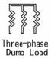

When the battery is full (the battery pressure reaching 125% of the

rated pressure), the controller will automatically carry out

Fuse burn
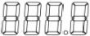

Polarity Reverse

three-phase dump load discharging to stop charging battery. Then

this image display.

When the battery voltage reduces to 108% of the rated pressure,

the three-phase dump load will stop discharging to automatically

recover battery charging. Then the image not displayed.

LCD display in digital form show the parameters value.

Fuse burn indicator light, when fuse burn, remind users replace the fuse.

Polarity Reverse indicator light, when the battery polarity reversed.

Remind users properly connected to the battery.

（3）.LCD display parameters browse

1）After plus electric, system is in viewing conditions, LCD display battery voltage:

Battery XXX.XV.

2）In viewing conditions, striking the front panel of the case, will according to

the following order cyclic display parameters.

8

Battery voltage → charge current → charge power → Wind turbine voltage → Wind turbine charge current → Wind turbine power → Solar panel voltage → Solar panel charge current → Solar panel power → Battery voltage.

- Box diagram
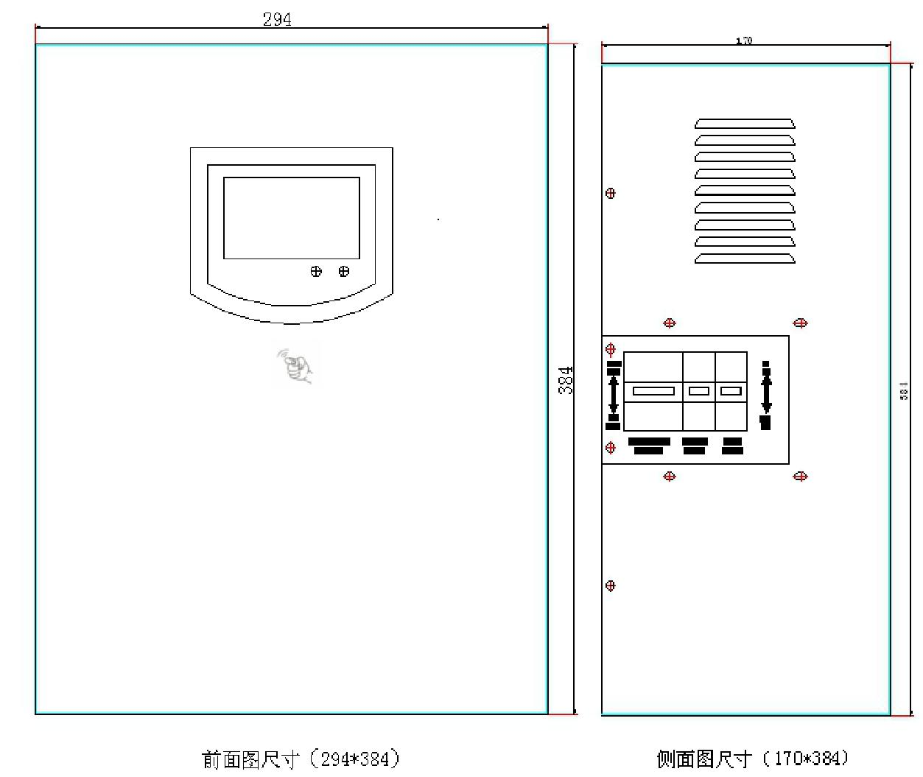
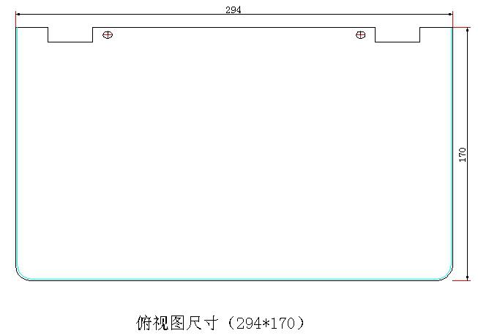

9

- Accident analysis

- When the wind turbine runs well but the controller has repeated “papa ", stop wind turbine immediately, Then check the insurance fuse and the connection of battery group are good or not, maybe the battery is damaged.
- After inserting the battery, if the voltmeter has no show, you should check the fuse broken or not, and whether the battery was connected well, the polarity was connected by mistake or the battery has already been damaged.

- Notice

This controller has already considered the possibility of any incidents in design, and adopts the matched protection method. But those protections are not perfect. The frequent restart of some function such as short-circuit-protect; inverse-connection-protect etc. will damage the internal components seriously. Therefore, the customer shouldn’t depend on these protect functions excessively. The following is very important for extend the equipments’ long-span:

1 The exhausted batteries and the connection are the main reason of failure.

1.1 Exhausted or the connection is not well can due to the charge voltage is too high or too low, over-charge or over-discharge, shunt, stop frequently, cannot work and the machine damage in the end.

1.2 We suggest you check the followings weekly: the battery voltage, capacity, connection and clean the “+”and “-” pole in time. (Please stop the wind turbine before settle the battery).

1.3 When the voltage of the storage battery falls to 85%, the “Power Shortage” button on the panel shines. Stop using immediately and charge the battery in

10

time. Or else, it will affect the life of the battery.

1.4 This equipment can’t charge the exhausted battery. If the battery’s voltage is under 75% of rated voltage, the wind turbine will stop work, please change for a new one or charge the battery separately.

- During charging, the temperature should be kept between 5~45 ℃.When the temperature is too high, detracting temperature measures or intermittent charging way should be taken. After charging, the injection plug should be spun tightly. Use clean water to wash the dirty or acid marks on the surface of the battery.

3. During using the battery, distilled water should be added constantly and acid is forbidden. Regular check should be taken. Before checking or repairing, the out-connected manual controller must be on “OFF”.

4. Do not connect the battery conversely to prevent the machine from being damaged.
5. It should connect with the ground to prevent from an electric shock.

- The Maintenance of the Batteries

It is very important to maintain the batteries. For different model or series, the maintaining measures of battery should be also different. For lead-acid batteries excepts the model maintenance-free, the following points should be paid attention to in daily maintains.

- The batteries should be always keep clean;

- Avoid any outside impurity matter drop into the batteries;

- All the tool and material should be placed in clean place with cover;

- The outside sulfuric acid trace and dust of the batteries should be periodic rub

11

away;

- Make sure the connect among each individual battery and the wires are reliable;
- The air-vent should be periodic checked and cleaned if the batteries have sealing cap and air-vent plug;
- Pay attention to the horizontal height of the electrolyte, both the pole plate and the insulating plate should not be higher than this height;
- The density of the electrolyte should be adjusted to its normal valve (1.28g/cm³,and this data can consult the specification), which can be carried out only when the batteries charging is finished;
- During the batteries discharging, the individual battery’s terminal voltage and electrolyte density less than permitted by the Regulation are forbidden;
10. The temperature of the electrolyte cannot exceed the value (45℃ generally) permitted by its Regulation;

11. In case the batteries are not use for a long time, these batteries should be charged once a month to avoid the exceeding over-automatic-discharge and the seriously sulphation.

12

- Schematic diagram
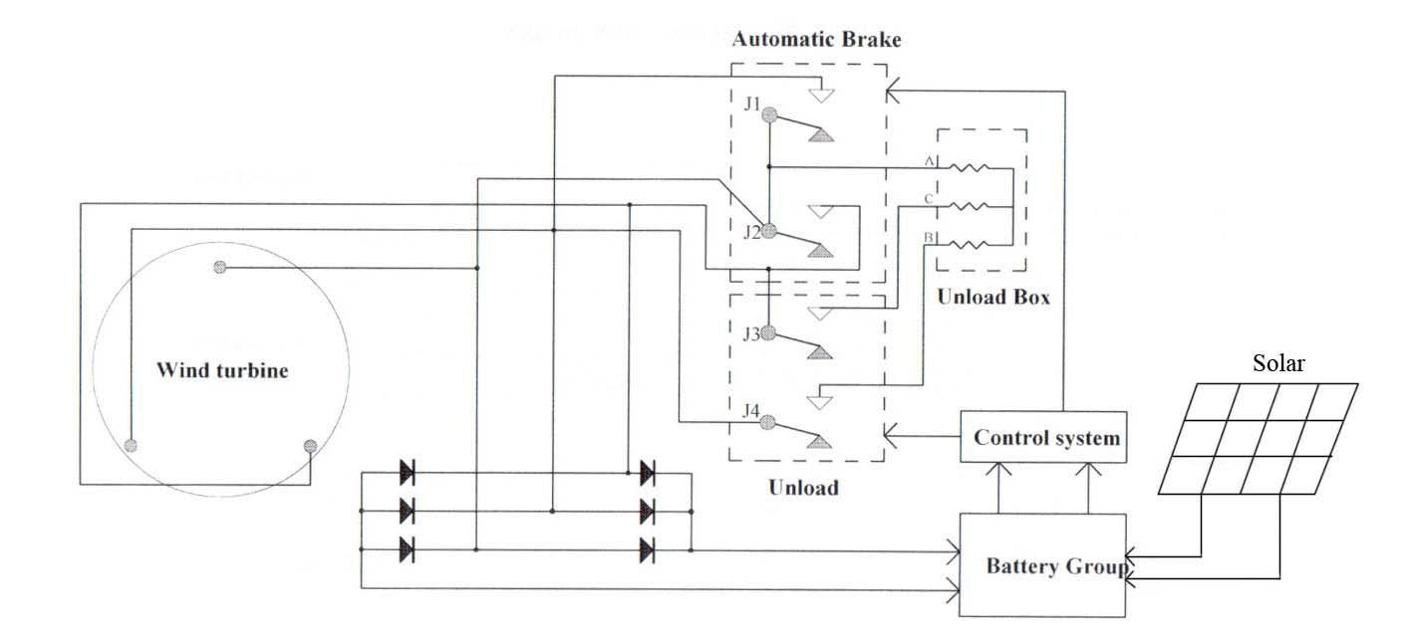

ⅩWiring diagram

Controller Unloader
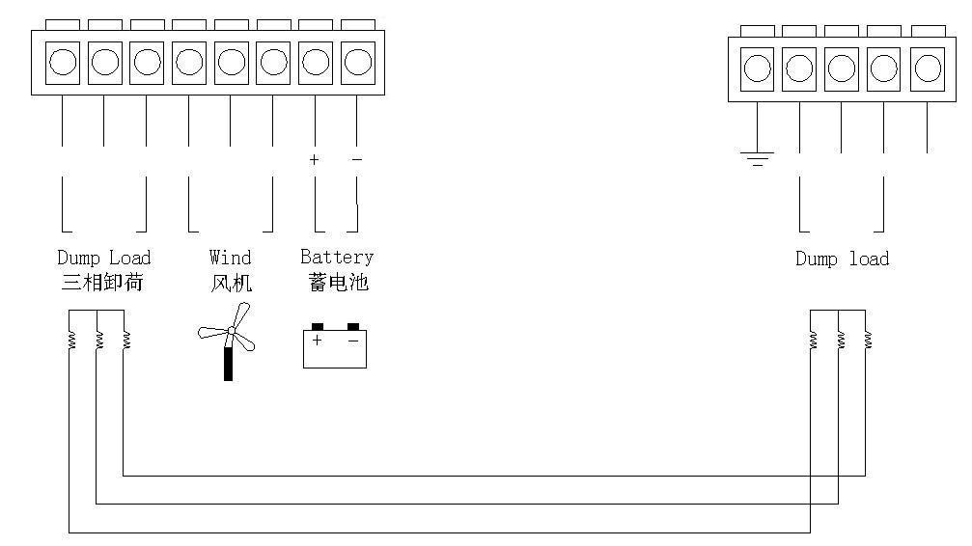

13

ⅩⅠ Technical Parameters

Wind power (W) | 1000
Matching battery groups(V) | 24
Function | Rectifier, charge, control
Display model | LCD
Display content | Wind turbine voltage, wind turbine current,
 | wind turbine power, solar panel voltage,
 | solar panel current, solar panel power,
 | battery voltage, charge current
Wind Turbine unload voltage (V) | 28±1
Wind Turbine Stop voltage (V) | 29±1
Wind Turbine restore charge voltage (V) | 26±1
Wire provide for battery (mm²) | >12
Work environment temperature | -30-60℃
Relative humidity | ＜90% No condensation
Noise (1m) | ＜40dB
Degree of protection | IP20（Indoor）
Cooling method | Forced air cooling
*Communication interface （optional） | RS485/USB/GPRS/Ethernet
*Temperature compensation （optional） | -4mv/°C/2V,-35°C~+80°C,Accuracy:±1°C
Size of the controller (mm) | 294*384*170mm
 | 14

Weight of the controller(KG) | 9kg
Size of the unloader (mm) | 290*250*120mm
Weight of the unloader(KG) | 5kg

Caution: For your security, please do the ground-connect well and reliably. This unloading box should settled in good ventilation and easy radiating

places, the inflammable and explosive materials are not allowed to be

arranged near the unloading box, the unloading box can not be covered

by other articles.

15

